DOCUMENT 1

President McKinley told a group of ministers visiting the White House how he came to his decision:

“Before you go I would like to say just a word about the Philippine business. . . . The truth is I didn't want the Philippines, and when they came to us as a gift from the gods, I did not know what to do with them. . . . I sought counsel from all sides -- Democrats as well as Republicans -- but got little help.

I thought first we would only take Manila; then Luzon, then other islands, perhaps, also.

I walked the floor of the White House night after night until midnight; and I am not ashamed to tell you, gentlemen, that I went down on my knees and prayed Almighty God for light and guidance more than one night. And one night late it came to me this way -- I don't know how it was, but it came:

1) That we could not give them back to Spain -- that would be cowardly and dishonorable.

2) That we could not turn them over to France or Germany, our commercial rivals in the Orient -- that would be bad business and discreditable.

3) That we could not leave them to themselves -- they were unfit for self-government -- and they would soon have anarchy and misrule over there worse than Spain's was; and

4) That there was nothing left for us to do but to take them all and to educate the Filipinos, and uplift and civilize and Christianize them, and by God's grace do the very best we could by them, as our fellow men for whom Christ also died. And then I went to bed and went to sleep and slept soundly.”

http://historymatters.gmu.edu/d/5575/

DOCUMENT 2

As a tropical product with a sensuous receptivity to the beauty of the world, he was not as easily reduced to be the mechanical draft-horse which the northern European laborer became. He ... tended to work as the results pleased him and refused to work or sought to refuse when he did not find the spiritual returns adequate; thus he was easily accused of laziness and driven as a slave when in truth he brought to modern manual labor a renewed valuation of life.

Thus husbands and wives were together only once every eight or ten months and when they met they were so exhausted and depressed on both sides ... they ceased to procreate. As for the newly born, they died early because their mothers, overworked and famished, had no milk to nurse them, and for this reason, while I was in Cuba, 7000 children died in three months. Some mothers even drowned their babies from sheer desperation.... in this way, husbands died in the mines, wives died at work, and children died from lack of milk . .. and in a short time this land which was so great, so powerful and fertile ... was depopulated. ... My eyes have seen these acts so foreign to human nature, and now I tremble as I write. ...

When he arrived on Hispaniola in 1508, Las Casas says, "there were 60,000 people living on this island, including the Indians; so that from 1494 to 1508, over three million people had perished from war, slavery, and the mines. Who in future generations will believe this? I myself writing it as a knowledgeable eyewitness can hardly believe it...

-Zinn

DOCUMENT 3

In that first year of the white man in Virginia, 1607, Powhatan had addressed a plea to John Smith that turned out prophetic. How authentic it is may be in doubt, but it is so much like so many Indian statements that it may be taken as, if not the rough letter of that first plea, the exact spirit of it:

I have seen two generations of my people die.... I know the difference between peace and war better than any man in my country. I am now grown old, and must die soon; my authority must descend to my brothers, Opitehapan, Opechancanough and Catatough-then to my two sisters, and then to my two daughters-I wish them to know as much as I do, and that your love to them may be like mine to you. Why will you take by force what you may have quietly by love? Why will you destroy us who supply you with food? What can you get by war? We can hide our provisions and run into the woods; then you will starve for wronging your friends. Why are you jealous of us? We are unarmed, and willing to give you what you ask, if you come in a friendly manner, and not so simple as not to know that it is much better to eat good meat, sleep comfortably, live quietly with my wives and children, laugh and be merry with the English, and trade for their copper and hatchets, than to run away from them, and to lie cold in the woods, feed on acorns, roots and such trash, and be so hunted that I can neither eat nor sleep. In these wars, my men must sit up watching, and if a twig break, they all cry out "Here comes Captain Smith!" So I must end my miserable life. Take away your guns and swords, the cause of all our jealousy, or you may all die in the same manner.

http://www.winkestleak.net/zinnz.html

DOCUMENT 4

Arawak men and women, naked, tawny, and full of wonder, emerged from their villages onto the island's beaches and swam out to get a closer look at the strange big boat. When Columbus and his sailors came ashore, carrying swords, speaking oddly, the Arawaks ran to greet them, brought them food, water, gifts. He later wrote of this in his log:

They ... brought us parrots and balls of cotton and spears and many other things, which they exchanged for the glass beads and hawks' bells. They willingly traded everything they owned... . They were well-built, with good bodies and handsome features.... They do not bear arms, and do not know them, for I showed them a sword, they took it by the edge and cut themselves out of ignorance. They have no iron. Their spears are made of cane... . They would make fine servants.... With fifty men we could subjugate them all and make them do whatever we want.

These Arawaks of the Bahama Islands were much like Indians on the mainland, who were remarkable (European observers were to say again and again) for their hospitality, their belief in sharing. These traits did not stand out in the Europe of the Renaissance, dominated as it was by the religion of popes, the government of kings, the frenzy for money that marked Western civilization and its first messenger to the Americas, Christopher Columbus.

Columbus wrote:

As soon as I arrived in the Indies, on the first Island which I found, I took some of the natives by force in order that they might learn and might give me information of whatever there is in these parts.

Howard Zinn’s A People’s History of the United States

<http://www.historyisaweapon.com/zinnapeopleshistory.html>

DOCUMENT 5

Anne Frank wrote in her diary:

Who has made us Jews different from all other people? Who has allowed us to suffer so terribly until now? It is God Who has made us as we are, but it will be God, too, Who will raise us up again.

Who knows ― it might even be our religion from which the world and all peoples learn good, and for that reason and that reason alone do we now suffer. We can never become just Netherlanders, or just English, or representatives of any other country for that matter. We will always remain Jews

DOCUMENT 6

How is this renewal of mankind to take place? Hitler declared:

The struggle for world domination will be fought entirely between us ― between Germans and Jews. All else is facade and illusion. Behind England stands Israel, and behind France, and behind the United States. Even when we have driven the Jew out of Germany, he remains our world enemy.

Hitler told his people:

Providence has ordained that I should be the greatest liberator of humanity. I am freeing man from the restraints of an intelligence that has taken charge, from the dirty and degrading self-mortifications of a false vision known as conscience and morality, and from the demands of a freedom and personal independence which only a very few can bear.

http://international.aish.com/seminars/whythejews/yjt08130.htm

**President Thomas Jefferson**, The Papers of Thomas Jefferson, December 29, 1813

“This unfortunate race, whom we had been taking so much pains to save and to civilize, have by their unexpected desertion and ferocious barbarities justified extermination and now await our decision on their fate.”

*Read more at* [*http://indiancountrytodaymedianetwork.com/2013/07/10/nice-day-genocide-shocking-quotes-indians-us-leaders-part-1-150362*](http://indiancountrytodaymedianetwork.com/2013/07/10/nice-day-genocide-shocking-quotes-indians-us-leaders-part-1-150362)

|  |  |
| --- | --- |
| bullet | **2001-NOV-16:** According to MSNBC, Franklin Graham appeared on the *NBC Nightly News*, commenting on Islam. He allegedly said: "*We're not attacking Islam but Islam has attacked us. The God of Islam is not the same God. He's not the son of God of the Christian or Judeo-Christian faith. It's a different God, and I believe it [Islam] is a very evil and wicked religion.*"  Slavery was, according to this argument, a good thing for the enslaved. John C. Calhoun said, "Never before has the black race of Central Africa, from the dawn of history to the present day, attained a condition so civilized and so improved, not only physically, but morally and intellectually.  http://www.ushistory.org/us/27f.asp |

David Quinn 1866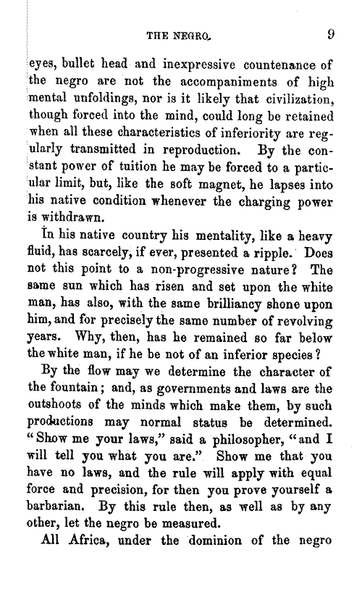

http://memory.loc.gov/cgi-bin/query/D?rbaapcbib:4:./temp/~ammem_Oztt::

We declare our right on this earth to be a human being, to be respected as a human being, to be given the rights of a human being in this society, on this earth, in this day, which we intend to bring into existence by any means necessary. Malcolm X

http://www.africanamericanquotes.org/malcolm-x.html