Practice assessments: Pre-Columbian Americas and Exploration
Short-Answer Questions
- “SIR: Since I know that you will be pleased at the great victory with which Our Lord has crowned my voyage, I write this to you, from which you will learn how in thirty-three days I passed from the Canary Islands to the Indies, with the fleet which the most illustrious king and queen, our sovereigns, gave to me. There I found very many islands, filled with people innumerable, and of them all I have taken possession for their highnesses, by proclamation made and with the royal standard unfurled, and no opposition was offered to me.

As soon as I arrived in the Indies, in the first island which I found, I took by force some of the natives, in order that they might learn and might give me information of that which there is in these parts. And so it was that they soon understood us, and we them, either by speech or signs, and they have been very serviceable. I still carry them with me, and they are always assured that I come from Heaven, for all the intercourse which they have had with me. They were the first to announce this wherever I went, and the others went running from house to house, and the neighbouring towns, with loud cries of, "Come! Come! See the men from Heaven!" So all, men and women alike, when their minds are set at rest concerning us, came, not one, small or great, remaining behind, and they all brought something to eat and drink, which they gave with extraordinary affection.”
- Letter to Luis de Santangel from Christopher Columbus describing his first arrival to Hispaniola. De Santangel had provided Queen Isabella with funds to finance Columbus’s journey.

For this question, address all parts:
  - Briefly explain Columbus’s attitude in regards to the native population.
  - Briefly explain how the first Spanish encounter with the native population impacted the future of their relationship.

- 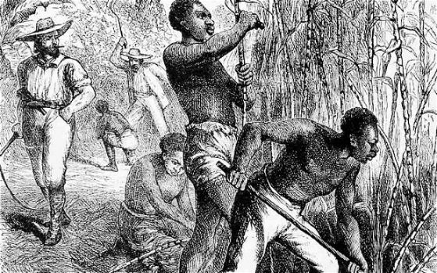
For this question, address all parts:
  - Briefly describe the labor system portrayed in the picture.
  - Briefly explain how the scene impacted the Caribbean World.

- 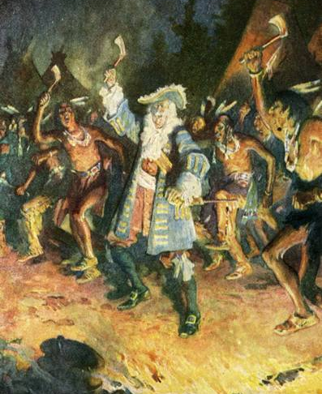

Frontenac with the Indians, by Charles William Jefferys, 1691
Frontenac was Governor-General of New France.

For this question, address all parts:
  - Briefly describe how the French viewed the native people in North America.
  - Briefly describe the significant differences between French and Spanish colonizers.
  - Briefly describe how the French fur trade impacted the lives of the Native Americans.

